CYBER VOCAB LIST 1 Name :

WORDS FOR THIS WEEK: Acronym, Address, Baud, Binary, Bit, Bookmark, Bounce, Browser, Byte, Chat.
 | 1 |  |  |  |  |  |  |  | 2 |  |  |  | 3
4

 |  |  |  |  |  |  |  |  |  |  | 5
 | 6 |  | 7
 |  |  |  |  |  |  |  | 8
 |  |  |  |  |  | 9 |  |  |  |  |  | 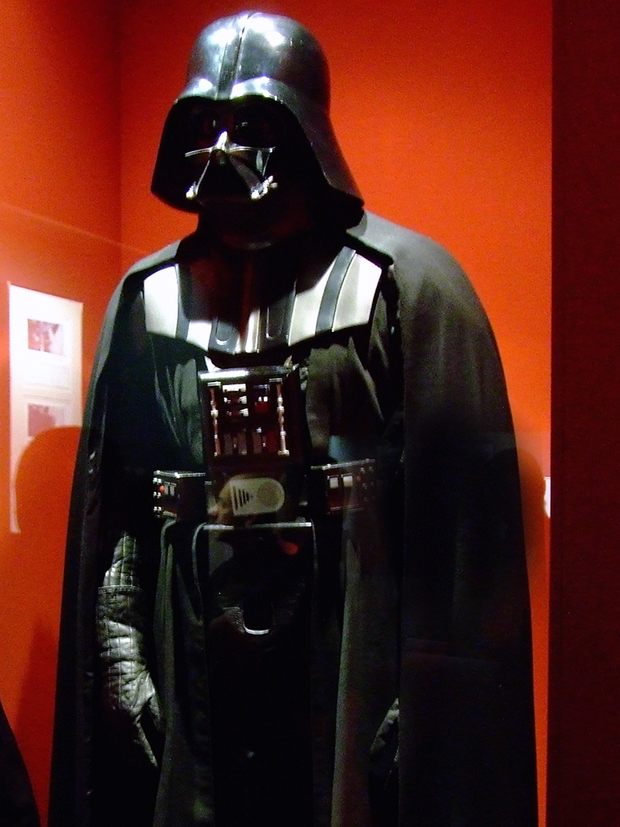
 |  |  |  |  | 10
 | 11
 |  | 12

ACROSS
1- Speed at which modems transfer data
2- When emails come back undeliverable
4- It lights the sky during the daytime
5- Unit of information equal to 8 bits, also represents one letter or number
6- Talking to someone on the computer by typing words on the computer keyboard.
8- Fast way of typing a phrase by using select letters from the phrase
10- Speed at which modems transfer data
11- A number system that uses only 1's and 0's; this is the way computers talk to each other.
12- A location in cyberspace

DOWN
1- When emails come back undeliverable
2- The smallest unit of information that can be sent among computers
3- Talking to someone on the computer by typing words on the computer keyboard
5- Marks your favorite web site in the browser
7- An example is HAND for Have a Nice Day
8- A location in cyberspace
9- Seven of these equal a week
10- A program that allows you to look at web sites on the Internet
11- A unit of information that represents one letter or one number

